- Identify and fix the error in the given SQL query that uses incorrect
JOIN syntax and returns duplicate results.
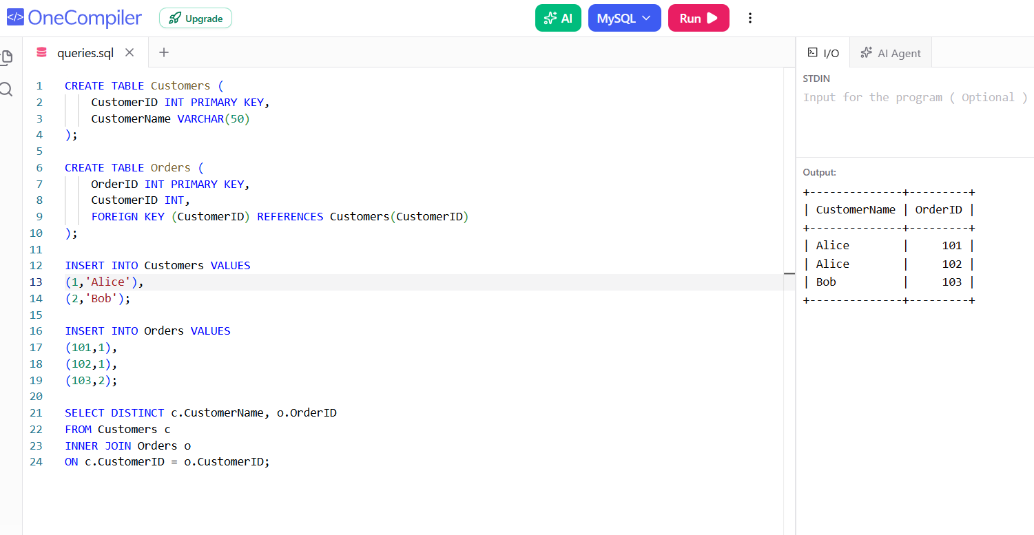

2) The following sub-query returns incorrect results due to a missing
correlation. Debug and rewrite it correctly.

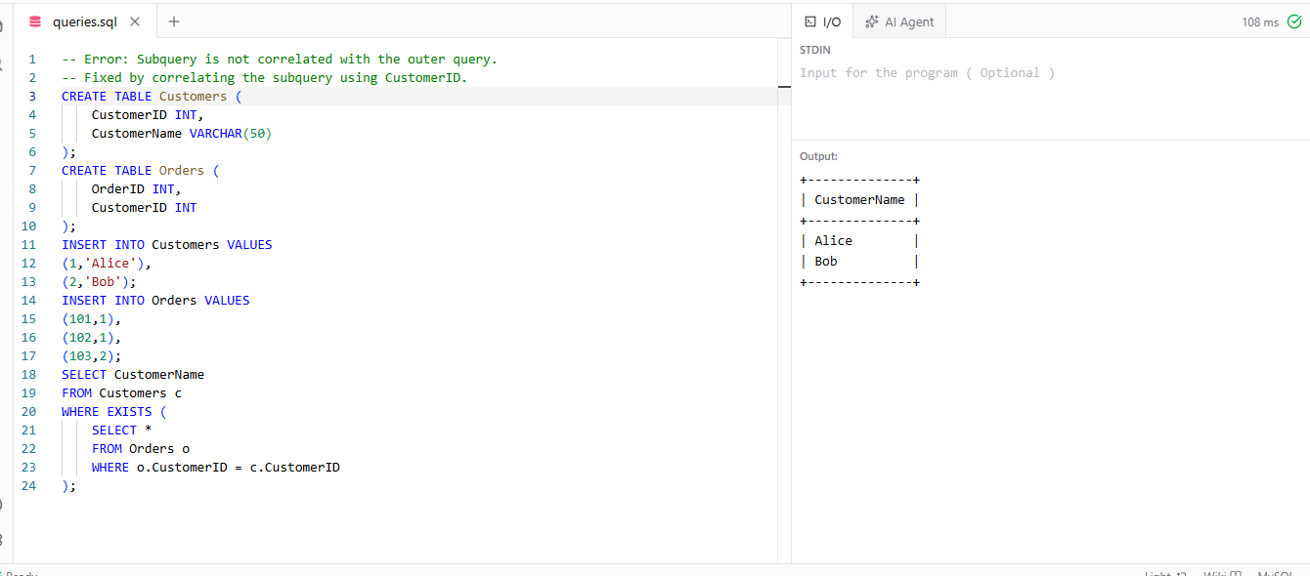
3) A given SQL view definition causes errors when queried. Identify
the issue and rewrite a correct and optimized view.
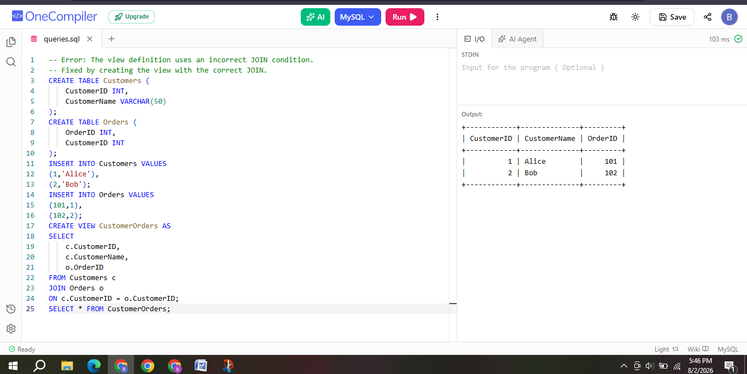4) Debug the given relational algebra expression that produces
incorrect output for a natural join operation.
Error:
The natural join was performed on unrelated or mismatched attributes ,which produced incorrect results.
Incorrect Expression:
Customers ⨝ Orders
Correct Expression:
Customers ⨝ Customers.CustomerID = Orders.CustomerID Orders
Explanation:
- The join must be performed using the common attribute CustomerID.
- Using the correct join condition returns only matching records and eliminates incorrect results.
.5) The SQL query below violates referential integrity. Identify the violation and modify the statements to enforce proper constraints.

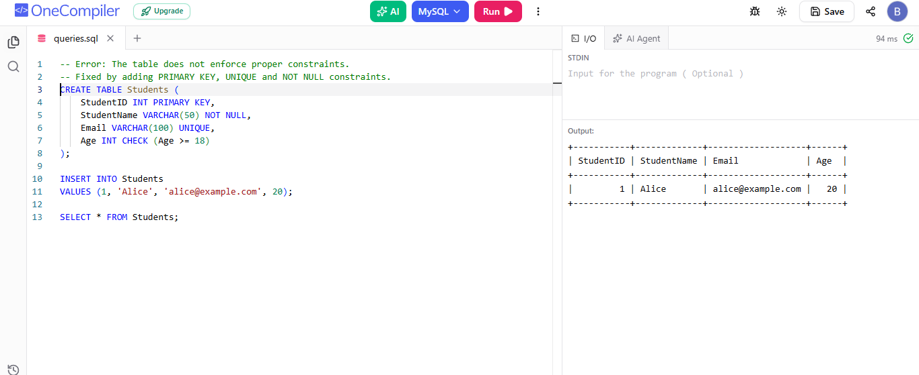

6) Given an inefficient SQL query with nested loops, rewrite it using JOIN to optimize performance.
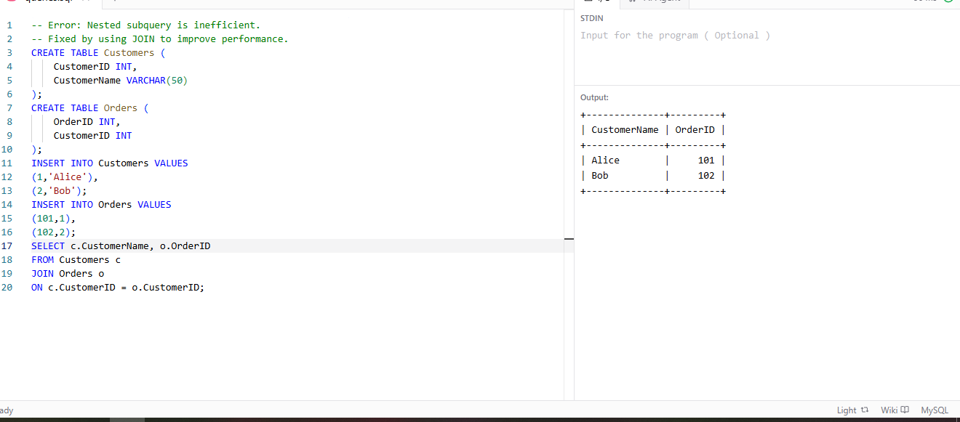

7) The GROUP BY query below produces wrong aggregation results. Debug the query and explain the error.
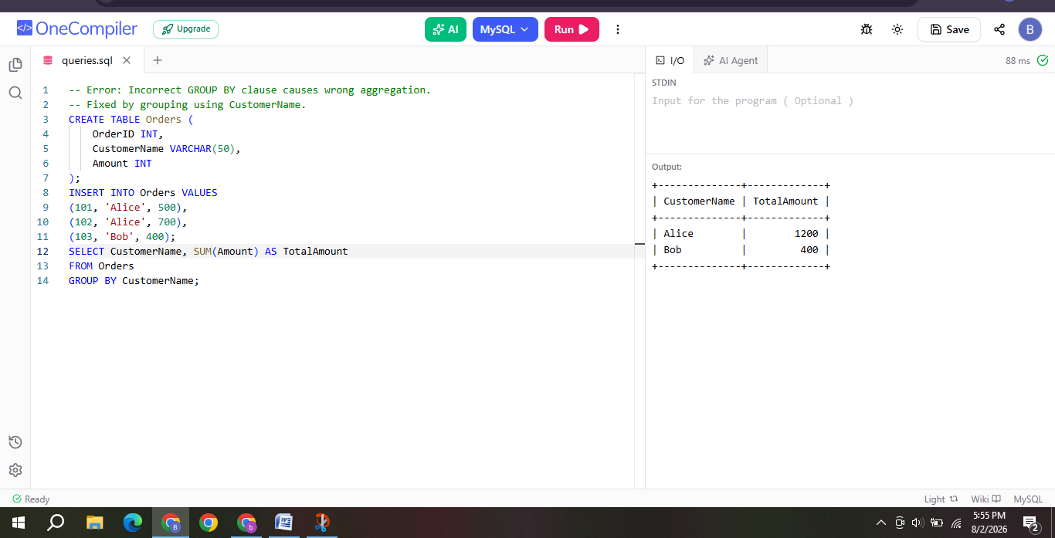

8) Identify and fix the logical error in a given SQL UPDATE statement that unintentionally modifies all rows in the table.
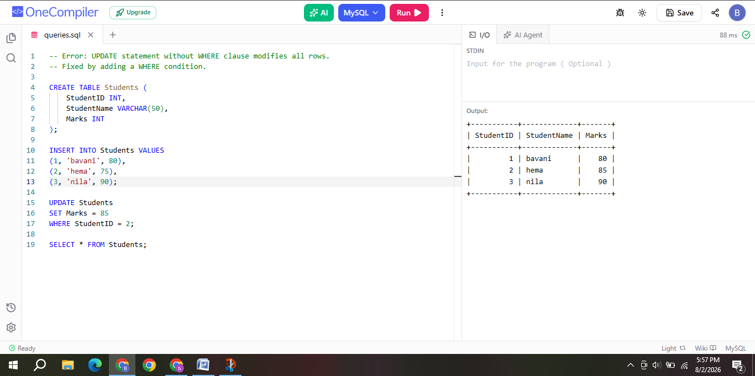
9) Optimize the given multi-table SQL query by restructuring sub-queries into JOINs and using appropriate indexes.
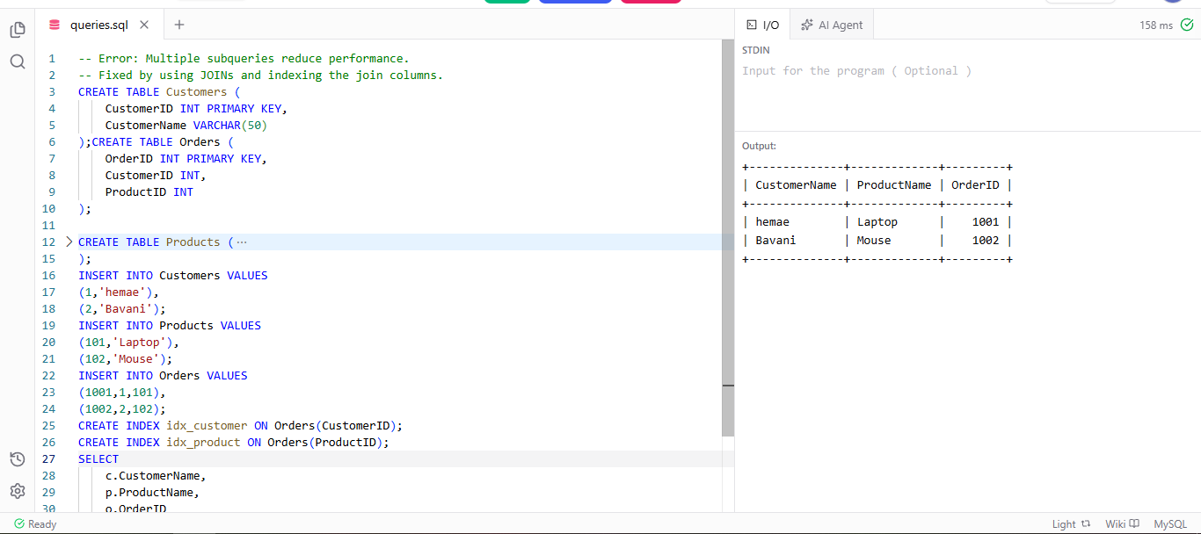
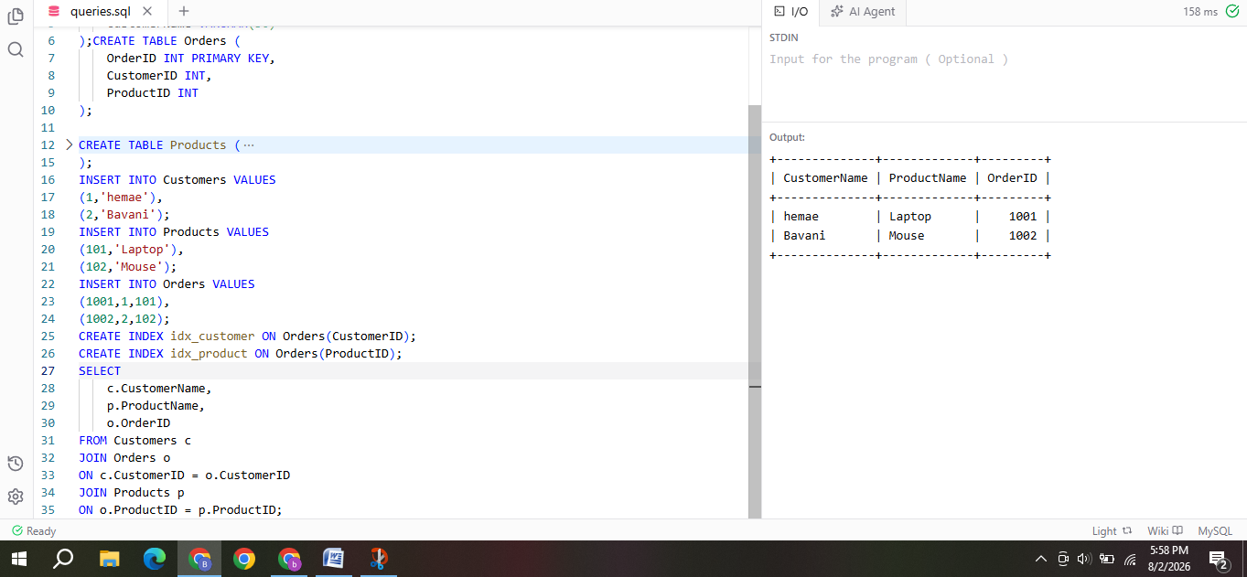

10) Debug a given relational calculus expression that returns an empty result set due to incorrect quantifier usage.
Error:
The expression incorrectly uses the universal quantifier (∀),
which causes the query to return an empty result.
Incorrect Expression:
{ x | Student(x) ∧ ∀y (Course(y) → Enrolled(x,y)) }
Correct Expression:
{ x | Student(x) ∧ ∃y (Course(y) ∧ Enrolled(x,y)) }
Explanation:
- The universal quantifier (∀) requires a student to be enrolled in every course, which usually returns no results.
- Replacing it with the existential quantifier (∃) returns students who are enrolled in at least one course.

